Heat Exchangers Design and Mechanical Summary Report
Client: Aarti Industries Limited
Consultancy Firm: Chemklub India
Project Code: SES-HE2024 (HE-007 and HE-008)
Report Date: December 12, 2024

Table of Contents
- Given Data
- Executive Summary
- Introduction
- Methodology
- Results and Analysis
- Recommendations
- Conclusion
- References
- Appendices

1. Given Data
Heat Exchanger 1-HE007
Fluid Allocation:
- Shell Side: Cooling water, 32°C (inlet) to 37°C (outlet).
- Tube Side: Water vapors, 115°C (inlet) to 40°C (outlet).
- Heat Exchanged: 161,000 kcal/h.
- Log Mean Temperature Difference (LMTD): 30.73°C.
Heat Exchanger 1-HE008
Fluid Allocation:
- Shell Side: Cooling water, 32°C (inlet) to 37°C (outlet).
- Tube Side: Water vapors, 115°C (inlet) to 40°C (outlet).
- Heat Exchanged: 152,419 kcal/h.
- Log Mean Temperature Difference (LMTD): 17.81°C.
Design Specifications (Applicable to Both Exchangers)
- Design Pressure: Shell side 6 kg/cm²g; Tube side 3 kg/cm²g.
- Design Temperature: Shell side 100°C; Tube side 150°C.
- Construction: Vertical, BEM configuration.
- Dimensions: Shell ID 430 mm, tube length 1000 mm.
- Tube Details: 250 tubes, 19.05 mm OD, 23.81 mm pitch.
- Material: SS 316 for shell, tubes, and baffles.

2. Executive Summary
Chemklub India collaborated with Aarti Industries Limited to evaluate and optimize two heat exchangers (1-HE007 and 1-HE008) designed for ONA dehydration condenser service. Both exchangers comply with TEMA standards and ASME Code Section VIII, Division 1, demonstrating robust thermal and mechanical performance. Key findings highlight efficient heat transfer capabilities and adherence to safety margins. Recommendations are provided for enhanced monitoring and potential future upgrades to sustain efficiency and reliability.

3. Introduction
3.1 Background
Aarti Industries Limited specializes in chemical production requiring high-efficiency heat exchangers for critical processes like ONA dehydration. Heat exchangers 1-HE007 and 1-HE008 operate as vertical BEM-type units serving this essential function.
3.2 Objectives
- Validate the thermal and mechanical design of both exchangers.
- Ensure compliance with TEMA and ASME standards.
- Provide actionable recommendations for performance enhancement.
3.3 Scope
This report encompasses the design validation, thermal and mechanical analysis, and operational optimization recommendations for both heat exchangers.

4. Methodology
- Data Collection: Comprehensive review of provided process data sheets and mechanical summary documents.
- Thermal and Mechanical Analysis: Conducted using Aspen Exchanger Design and Rating (EDR) software.
- Compliance Review: Verified against TEMA standards (Class B) and ASME Code Section VIII Division 1.
- Reporting: Consolidation of findings and recommendations for future optimization.

5. Results and Analysis
5.1 Design Specifications
- Configuration: BEM, vertical.
- Shell Dimensions: ID 430 mm, OD 436.35 mm.
- Tube Details: 250 tubes, 19.05 mm OD, 1000 mm length, 23.81 mm pitch.
- Material: SS 316 for all components.
5.2 Thermal Performance
- Heat Exchanged: 1-HE007: 161,000 kcal/h; 1-HE008: 152,419 kcal/h.
- LMTD: 1-HE007: 30.73°C; 1-HE008: 17.81°C.
- Pressure Drops: Shell: 0.32 kg/cm²; Tube: 0.137 kg/cm².
- Fouling Resistance: Shell side: 0.00061 m²•h•°C/kcal; Tube side: 0.00013 m²•h•°C/kcal.
5.3 Mechanical Integrity
- Design Conditions: Pressure 6 kg/cm²g; Temperature 150°C.
- Compliance: ASME Section VIII Division 1, TEMA Class B.
- Baffle Type: Single segmental, 250 mm spacing.
- Impingement Protection: Not required based on flow conditions.

6. Recommendations
- Monitoring: Periodic inspection for fouling and adherence to cleaning protocols.
- Performance Optimization: Evaluate fluid velocities to avoid localized overheating or erosion.
- Future Upgrades: Consider advanced materials for enhanced corrosion resistance in harsh environments.

7. Conclusion
Both heat exchangers (1-HE007 and 1-HE008) meet the required design and operational standards. They demonstrate efficient performance with adequate safety margins, ensuring reliability for ONA dehydration processes. Recommendations provided aim to enhance long-term operational efficiency.

8. Setting Plan Design and Tubesheet Layout: HE-007
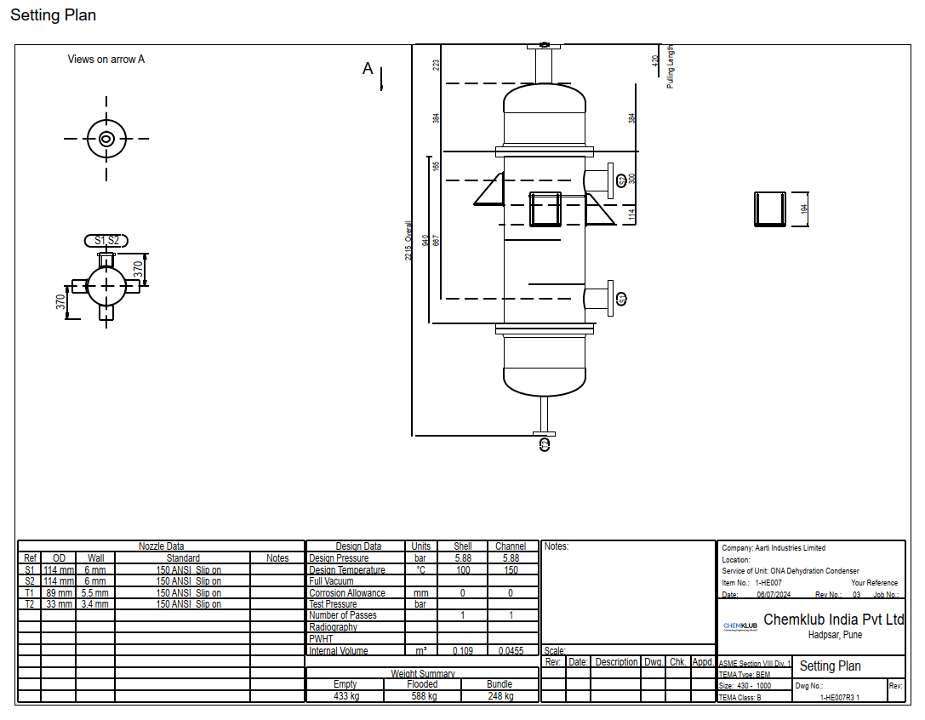

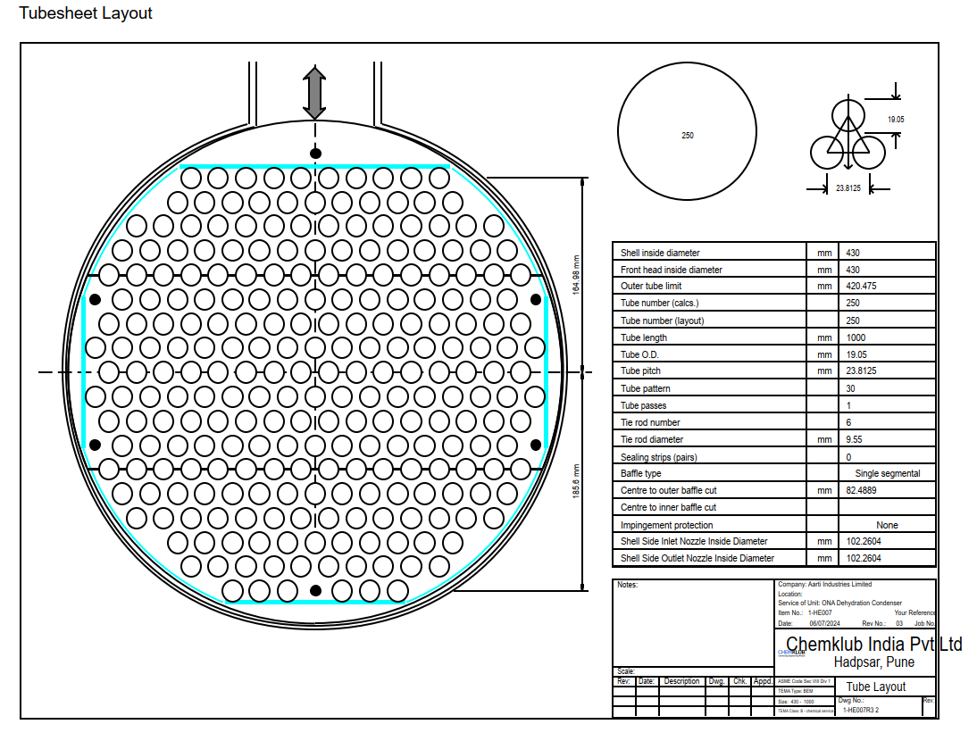
9. Setting Plan Design and Tubesheet Layout: HE-008
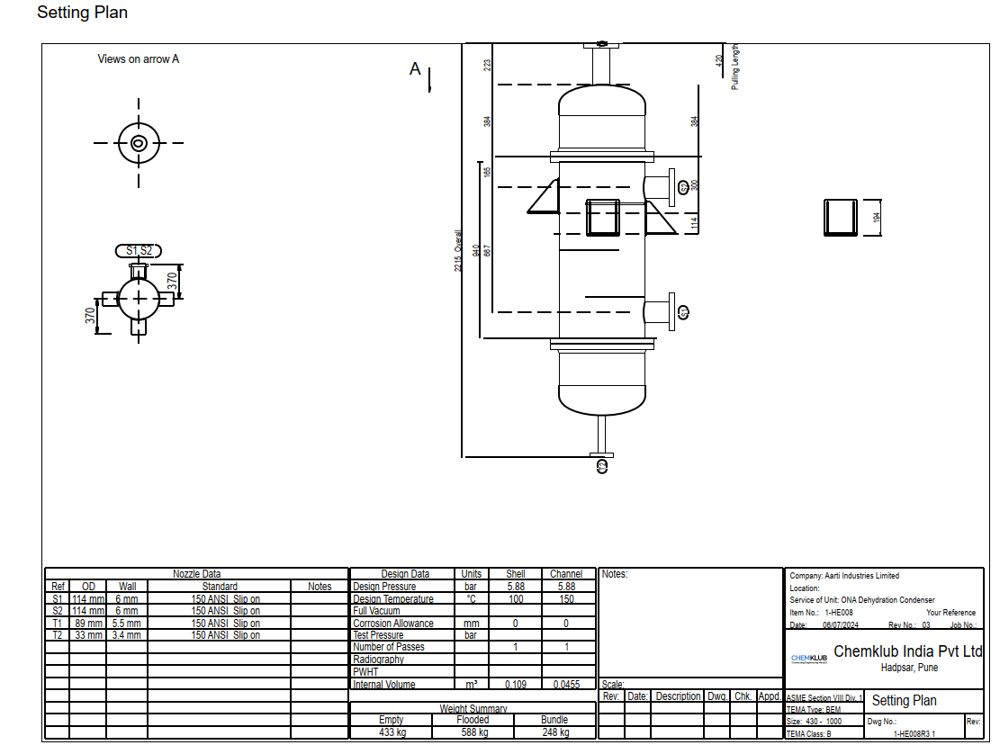

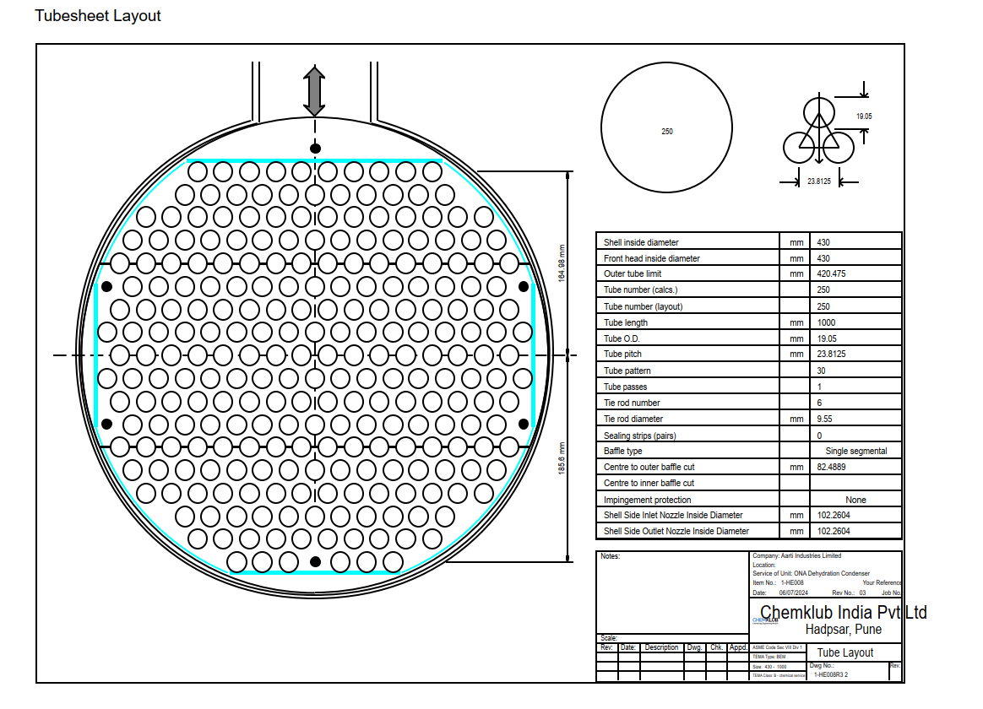

10. References
- TEMA Standards for Shell and Tube Heat Exchangers.
- ASME Code Section VIII Division 1.
- Aspen Exchanger Design and Rating Software Documentation.
- Process Data Sheets for 1-HE007 and 1-HE008.

11. Appendices
- Appendix A: Detailed Performance Data Tables.
- Appendix B: Placeholder for Heat Exchanger Sketches.
- Appendix C: Additional Calculations.

